**Thermistor Circuitry**

**1) Physical Geometry**

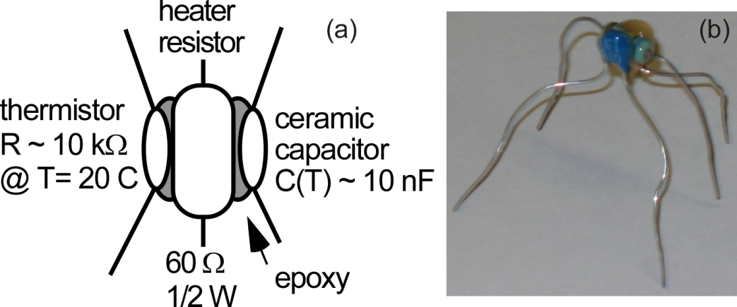

Fig. 1. The bug: A 10 k silicon thermistor, a ½ Watt 60  metal film heater resistor, and a 10 nF ceramic capacitor epoxied together to form an integrated breadboard-based experimental system. (a) A schematic. (b) An image from the thermistor side.

**2) Heater Resistor and Thermistor Circuit**



manual circuit

Fig. 2. A circuit schematic of the heater resistor and the thermistor for control of the temperature. The variable power supply should be **limited to ~ 8 Volts** to avoid overheating the system above ~ 85 oC and thus damaging the epoxy or the bug components.

The thermistor resistance to temperature conversion is the widely-used Steinhart-Hart equation:

.

where T is in K and R is in .